1. For this exercise, we will start by creating a new project and add a screen to it, so please follow the same steps as in the tutorial “How to create the first screen of your app”.

Level of difficulty:   
Estimated time: 5 mn

[**www.codapps.io**](http://www.codapps.io)by Clement Levallois **@codapps_io** [**www.coursera.org/learn/codapps**](http://www.coursera.org/learn/codapps)



**Module 2: How to add text, pics, links etc. to your app**

*How to add a screen to the app, and how to navigate between screens*

You should end up with a file called “Screen1.java”:

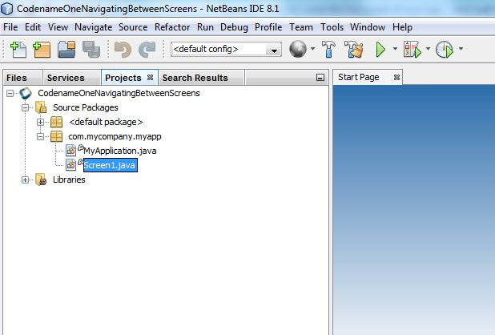

And in the file “MyApplication.java”, you should have changed this code, to make sure Screen1 is shown when the app starts (not sure what this code is? Check again the tutorial “How to create the first screen of your app”):

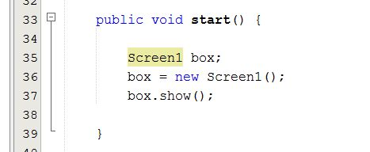

1. Create a second screen and call it “Screen2”. To do this, just follow the same steps as when you created Screen1: right click on the name of the project, then “new”, then “Others”, then “GUIBuilder Form”, then write the name “Screen2”.
2. You should end up with these files:

Level of difficulty:   
Estimated time: 5 mn

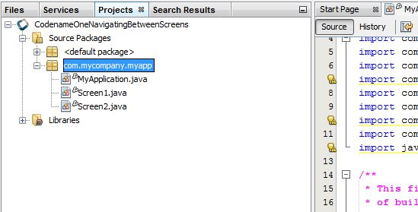

1. Let’s open Screen1 and add a button to it: you should be able to do that since you followed the tutorial “How to add a button to the screens of my app.

[**www.codapps.io**](http://www.codapps.io)by Clement Levallois **@codapps_io** [**www.coursera.org/learn/codapps**](http://www.coursera.org/learn/codapps)



**Module 2: How to add text, pics, links etc. to your app**

*How to add a screen to the app, and how to navigate between screens*

”

1. Add a button to Screen 2.
2. Now, we want that clicking on the button from Screen1 makes Screen2 appear, and we want that clicking on the button on Screen2 switches back to Screen1.

**Screen1 and Screen2**

To make that happen, we will need to add a couple of lines of code. These lines are going to be explained much better in module 5, but I thought that you already wanted to know how to use different screens for your app, because that’s very basic and useful?

So let’s do it. I explain for the button of Screen1, you just have to do the same logic for the button of Screen 2.

(see next page).

1. So, you have your Button on Screen1. Select it (I tshould be surrounded in green borders on the right).

Make sure you are show its properties by clicking on

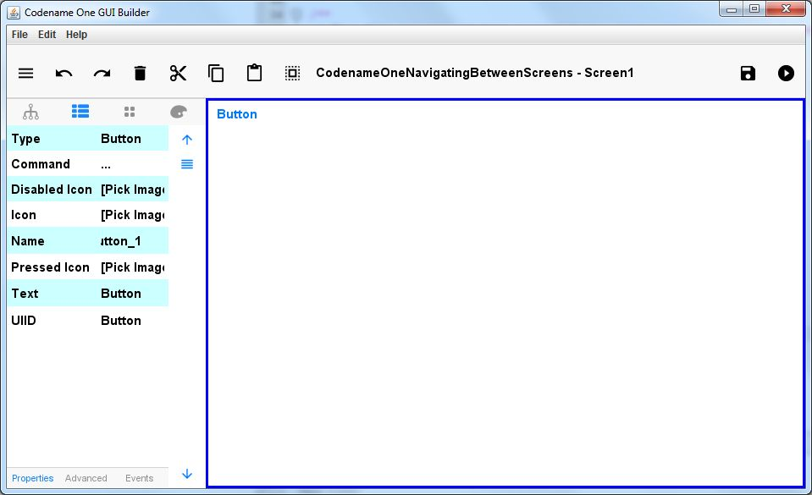Then click on “Events” at the bottom

1.  Now, click on Action Event:

Level of difficulty:   
Estimated time: 5 mn

[**www.codapps.io**](http://www.codapps.io)by Clement Levallois **@codapps_io** [**www.coursera.org/learn/codapps**](http://www.coursera.org/learn/codapps)



**Module 2: How to add text, pics, links etc. to your app**

*How to add a screen to the app, and how to navigate between screens*

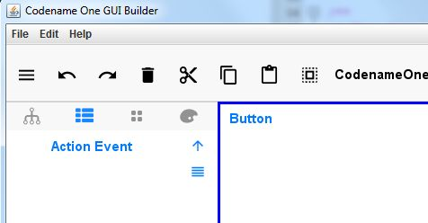

1. When you clicked, this has automatically written some code inside your file “Screen1” in NetBeans.

Level of difficulty:   
Estimated time: 5 mn

[**www.codapps.io**](http://www.codapps.io)by Clement Levallois **@codapps_io** [**www.coursera.org/learn/codapps**](http://www.coursera.org/learn/codapps)



**Module 2: How to add text, pics, links etc. to your app**

*How to add a screen to the app, and how to navigate between screens*

What has been written is the function that will be executed when somebody clicks on the button.

At the moment, this function is empty. We will add just 3 lines of code, that will say “create Screen2 and show it”. This way, when somebody clicks on the button on Screen1, the screen of the app will change and show Screen2 – you just made your user navigate between 2 screens in the app!

These are the 3 lines of code you should write, precisely between the 2curly braces circled in red:

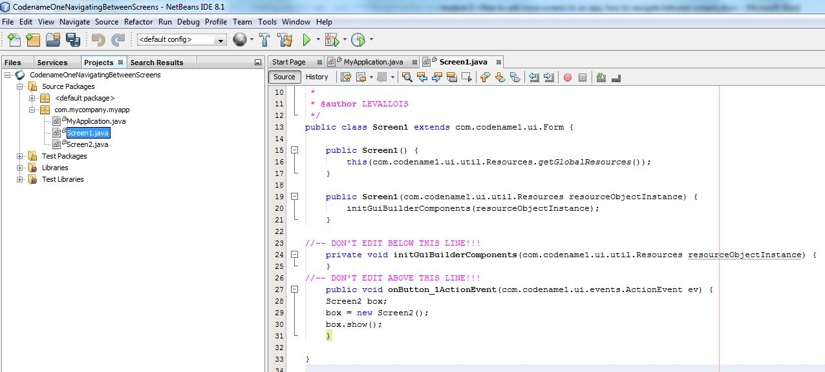

The 3 lines of code you should write !

Now if you launch your app (right click on the name of your project, then choose “Run” in the menu), you will see Screen1 appear. Click on the button, and it moves to Screen2. But you are stuck there!

To enable the users of the app to move back to Screen1 from Screen2:

* Create a Button on Screen2.
* Click on “Action Event” for this button.
* Add three lines of code to show Screen1, just like above but in Screen2.java

I leave it to you as a simple exercise!